CAMP WEE LUV’EM Teens
 | June/July 2017
Sun | Mon | Tue | Wed | Thu | Fri | Sat
June 25  WELCOME TO CAMP!! | 26  Friendship Games  Walking trip for Lunch | 27  Team Building Games | 28  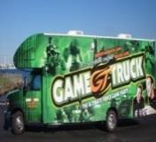  Game Truck  comes to Camp (Teens & Pre-teens) | 29  Water Slide | 30  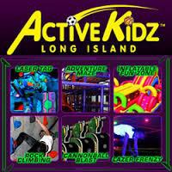  Trip to ActiveKidz | 1
2  Mad Science Week | 3  Red, White, and Blue Day  Walking trip for Lunch | 4  Camp Closed  Happy 4th of July!! | 5  Trip to Bounce Trampoline, Syosett  (Teens & Pre-teens) | 6  Floam | 7  Circus comes to camp | 8
9  Camp Crazy Week | 10  Velcro Wall  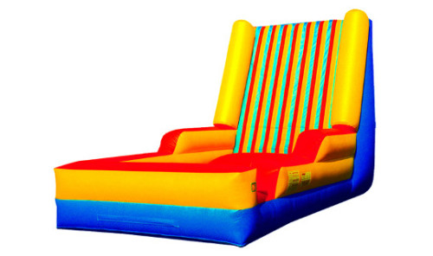  Walking trip for Lunch | 11  Decade Day | 12  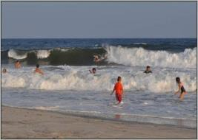Jones Beach | 13  Halloween in July | 14  Ice Skating at  Dix Hills Rink  (12:30-4:30) | 15  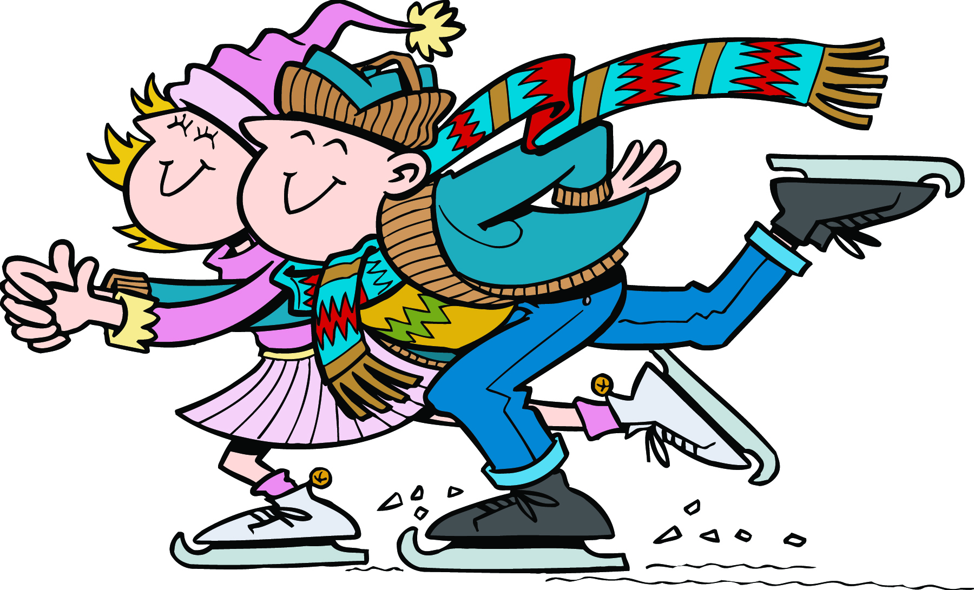
16  Adventure Week | 17  Obstacle Course  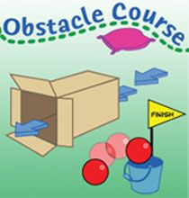  Walking trip for Lunch | 18  Super Villain Day | 19  Trip to Lazer Land  Teens & Pre-Teens | 20  Survivor Day  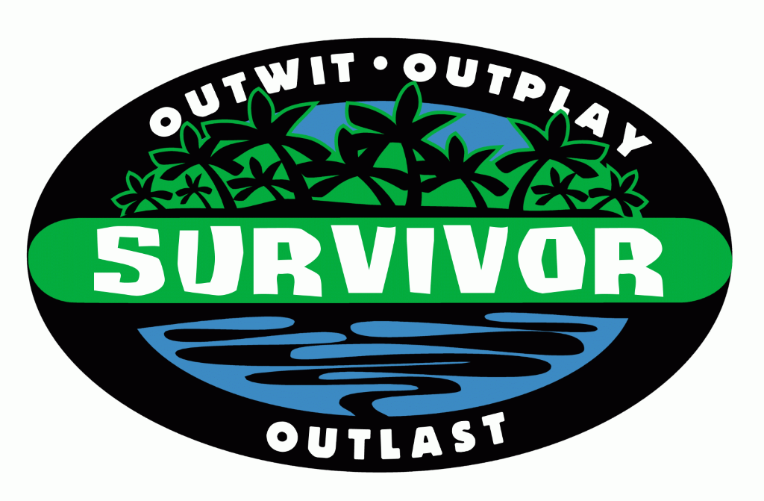 | 21  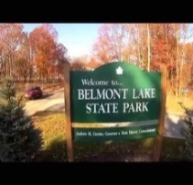  Trip to Belmont Park | 22  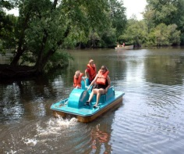
23 | 24  Capture the Flag and Team Cheer  Walking trip for Lunch | 25  Tee Pee Building Contest  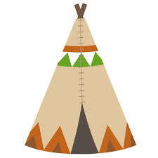 | 26  Zip Lining Trip | 27  Tie Dye and Race around Camp | 28  Trip to Country Fair | 29  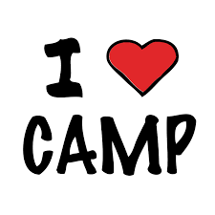

CAMP WEE LUV’EM Teens
 | August/September 2017 |  |  |  |  |  | ►
Sun | Mon | Tue | Wed | Thu | Fri |  | Sat
Reality TV Week | 31  Cake Boss  Walking trip for Lunch | 1  America's Next Top Model | 2  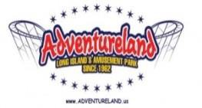Trip to Adventureland with Pre-Teens  (10:00-4:00) | 3  Talent Show | 4  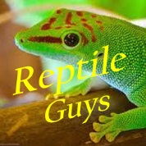  The Reptile Guys Come to Camp  Soc Hop |  | 5
6  Olympic Week | 7  Opening Ceremony and Water Wars  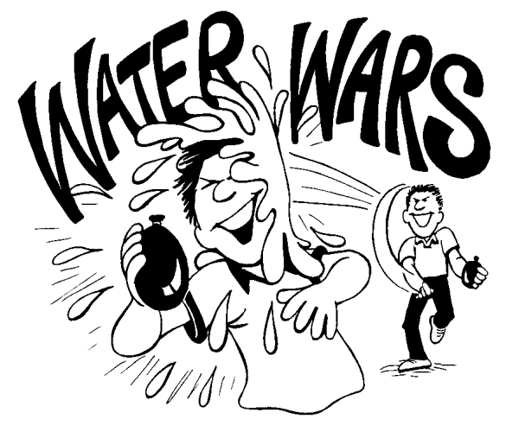  Walking trip for Lunch | 8  Capture The Flag | 9  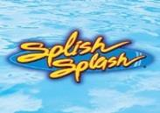  Trip to Splish Splash  (9:00-4:00) | 10  Teens vs. Veterans  Tennis Challenge | 11  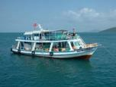  Fishing Trip (10:00-4:00) |  | 12  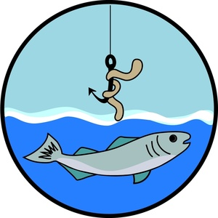
13  Wacky Week | 14  Hippy Day  Walking trip for Lunch | 15  Crazy Sock Day  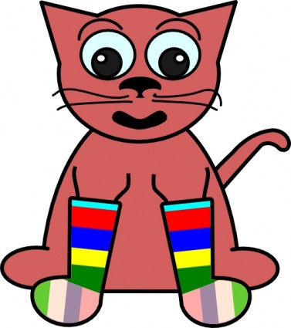 | 16  Bowling Trip  (Teens & Pre-Teens) | 17  Wacky Races  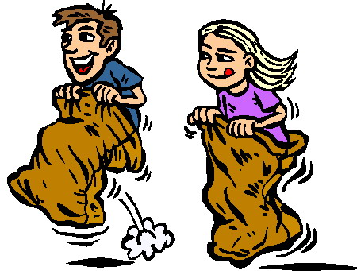 | 18  Trip to C&B Archery with Pre-Teens  (9:00) |  | 19  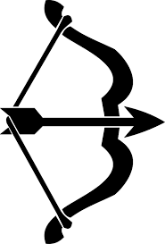
20  Carnival Week | 21  Sand Art  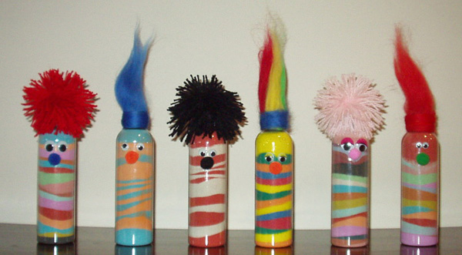Walking trip for Lunch | 22  Face Paints  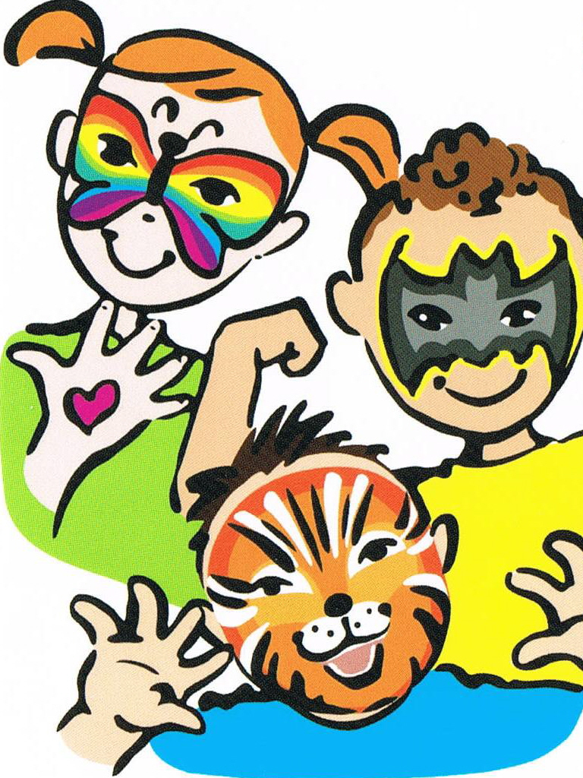 | 23  Trip to Tiki Action  Park, Centereach | 24  Group Carnival Booth  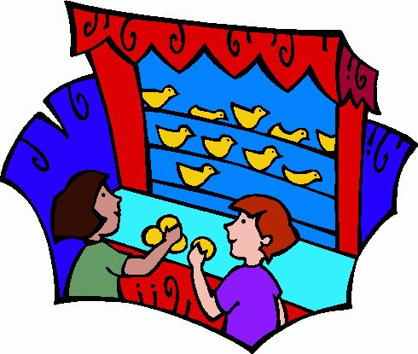 | 25  Carnival at Camp! |  | 26  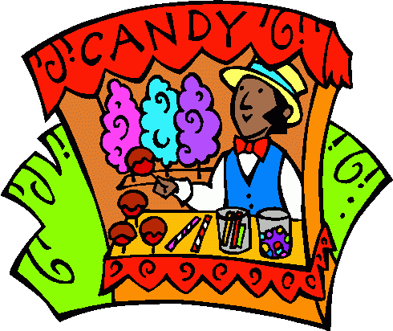
27 | 28  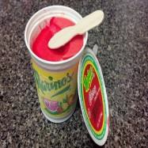  Italian Ices | 29  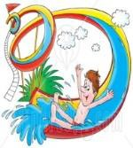Waterslide at Camp | 30 | 31  Snow Cones | September 1  Last Day of Camp! | 2  Have a Great School Year!!

